Nara Cheyklin Student ID: 6538097021
Hw1: Pub and Sub
- Create Turtlesim_node:
Command: ~/ros2_ws# ros2 run turtlesim turtlesim_node
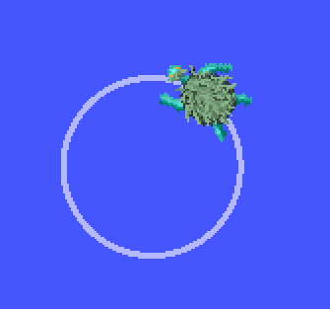
- Create a node to publish velocity commands to turtlesim node to make the turtle move in the following paths: 1.1.
Circle
Command: ros2 run hw1 turtle_walk

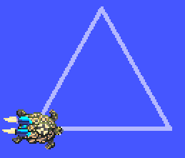
Triangle
Command: ros2 run hw1 turtle_walk --ros-args -p shape:=triangle

- Create a node to subscribe to the current turtle position from the turtlesim and send velocity commands back to the turtlesim node to make the turtle to draw the shape of two letters (The first letter is the first letter of your first name and the second letter is the first letter of your last name)
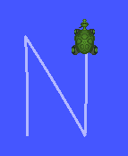
The first letter = ‘N’
Command:: ros2 run hw1 turtle_letter N

The second letter = ‘C’
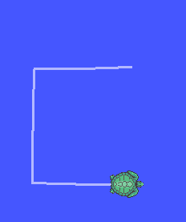
Command:: ros2 run hw1 turtle_letter C

